Roadkill Hotspots and Policy Advocacy: An AI and IoT-Based Approach

Abstract  Roadkill incidents pose a significant threat to wildlife, causing thousands of animal deaths due to vehicle collisions each year. This research introduces an AI-driven solution that detects high-risk animal crossings using YOLOv5xu for object detection and DenseNet/EfficientNet-based CNN models for classifying animals as dead or alive. The system integrates IoT sensors (ESP32, ultrasonic, DHT) for real-time monitoring and driver alerts. Additionally, heatmaps and predictive analytics help identify roadkill hotspots to drive policy changes for safer roads.  The project follows a multilayered approach with three dimensions:  D1: Computer Vision (YOLOv5xu) – Detects animals, movement speed, and classifies risk.  D2: ML Model (DenseNet + EfficientNet) – Determines if the detected animal is dead or alive.  D3: IoT-Based System (ESP32, Ultrasonic Sensors) – Alerts drivers in real-time when an animal is detected.  1.1 Flow Chart of Multilayered Approach  1. Introduction  - Background & Theme  With increasing urbanization and expanding road networks, wild and stray animals frequently encounter vehicles, leading to fatal accidents. Some studies have reported over 300+ roadkill  2. Technology Stack  2.1 AI-Based Animal Detection (YOLOv5xu)  To ensure reliable detection, YOLOv5xu is trained on real-world highway video footage and images. The model identifies species, movement patterns, and potential risk levels. It is enhanced with Farneback Optical Flow to estimate speed and behavior, improving overall accuracy. The system is deployed across five interfaces using Gradio, each optimized for different processing capabilities.  YOLOv5xu Detection Output  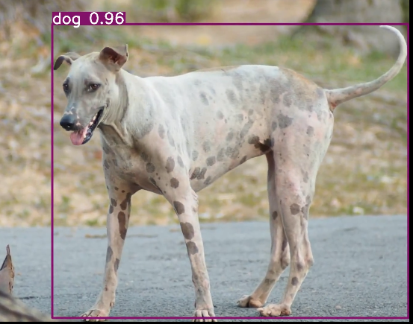  2.2 CNN-Based Dead/Alive Classification  The classification module leverages DenseNet121 and EfficientNet-B3, achieving 94-98% accuracy. To enhance model generalization, L2 regularization and dropout techniques are applied, preventing overfitting. This module is hosted via a Flask API for real-time classification.  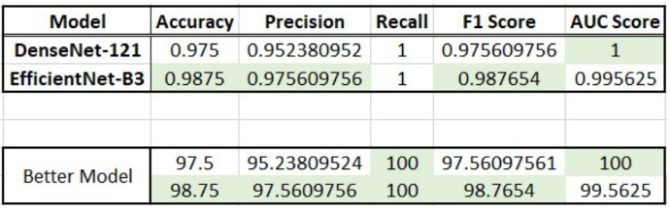  2.3 IoT Integration for Real-Time Alerts  The IoT subsystem processes YOLOv5xu outputs using an ESP32 module. Ultrasonic | cases within 10 months, significantly impacting biodiversity.  1.2 Objective  This project aims to:  - Detect animals on roads in real time using computer vision (YOLOv5xu).  - Classify if the detected animal is alive or dead using CNN-based models.  - Predict risk levels using optical flow-based movement tracking.  - Warn drivers through IoT-based smart signage.  - Generate heatmaps to inform policymakers about high-risk zones.  1.3 Multilayered Approach  The system follows a three-dimensional AI-based solution for real-time roadkill prevention:  D1: Computer Vision (YOLOv5xu)  - Detects animals & objects in real time.  - Identifies if the animal is dead or alive.  - Tracks animal movement speed and detects sudden movements.  D2: ML Model (DenseNet + EfficientNet)  - Classifies animals as dead or alive with 94%-98% accuracy.  - Integrated with a Flask-based web interface for real-time processing.  D3: IoT-Based System (ESP32, Ultrasonic Sensors)  - Detects obstacles near highways.  - Smart signage with LED and buzzer alerts drivers.  - DHT Sensor measures environmental impact factors like temperature and humidity.  sensors detect object proximity, and upon detecting an animal, the system triggers a buzzer and LED warning mechanism to alert approaching drivers.  3. System Design & Implementation  3.1 AI-Based Roadkill Detection (D1 & D2)  The system operates through a structured detection and classification process:  - Capture video feed using dashcams, traffic cameras, or highway surveillance.  - Apply YOLOv5xu to detect animals and classify them as high risk if sudden movements are detected.  - If the animal is stationary, CNN-based classification determines whether it is alive or dead.  - If the animal is alive, the IoT-based alert system is triggered to warn drivers.  - If the animal is dead, an alert notification is sent to the municipal corporation for disposal.  